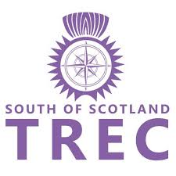


SoS TREC
PTV training (Mounted)

Who: Anyone. Beginner to advanced. All welcome, members and non members.

What: A selection of PTV obstacles

Why: Get to know the rules of and ride the obstacles.

When: Saturday August the 15th 1.5 hour sessions, no more than 3 per group.

Where: Hyndshawland Farm Stables, Elsrickle, South Lanarkshire, ML12 6RD

How Much: SoS TREC members £20.00
Non members £25.00

Come along to learn about the obstacles and gain knowledge of how to improve to gain more marks. Increase your skills so that when you are out at a competition on your horse you feel more confident.
All levels taught. Please state the level of TREC that you ride in. (Doesn’t matter if you have not done TREC before, Just let us know)
All horses must be insured and vaccinated. Please email a copy of your ins and vac record with your entry form. E mail to: still.dorothy@gmail.com. A disclaimer will then be sent to you to complete.
Please complete the entry form below, email to still.dorothy@gmail.com and send your entry fee to South of Scotland TREC, 80-22-60, 15278467. Please reference your surname and PTV HFS along with your payment.

Name
Address

Post Code
Phone number
Email
Emergency Contact (name and number)

TREC experience:
What do you want to get out of the training?

Any other information the trainer should know about?

